**System Design Document for Digitalization of Admissibility Project**

1. Project Overview

* **Title:** Digitalization of Admissibility - One ID
* **Purpose:** To streamline the check-in process by enabling the digital verification of passengers’ travel documents, thus reducing queues and congestion at airports.

2. System Overview

* **Description:** The system allows passengers to use a digital identity wallet to store and share verifiable credentials (VCs), such as passports and visas, with airlines to automate the check-in process.

3. Architectural Design

* **System Architecture:** The architecture includes a passenger-facing app (digital identity wallet), an airline check-in system, and a verification system (for validating credentials against government databases).
* **Components:**
  + Digital Identity Wallet: A mobile application where passengers can securely store and manage their digital travel documents.
  + Airline Check-In System: A web-based or kiosk system that interfaces with the digital identity wallet to retrieve and verify VCs.
  + Verification System: A backend service that validates the VCs against government or issuing authority databases.

4. Functional Requirements

* Passengers must be able to upload and store travel documents in the digital identity wallet.
* The airline check-in system must be able to retrieve VCs from the digital identity wallet with the passenger’s consent.
* The verification system must authenticate the VCs against a trusted source.

5. Non-Functional Requirements

* **Security:** Ensure end-to-end encryption for data transfer between the digital identity wallet, airline check-in system, and verification system.
* **Scalability:** The system must handle high volumes of check-ins, especially during peak travel times.
* **Usability:** The user interface for the digital identity wallet and check-in system should be intuitive and easy to navigate.

6. Data Flow Diagram

* Illustrate the flow of information between the passenger, digital identity wallet, airline check-in system, and verification system.

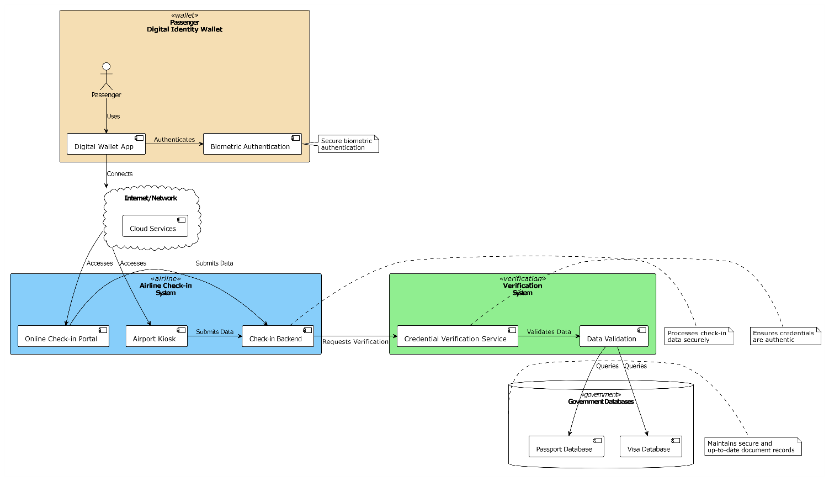

7. Integration Points

* Government document issuing systems for real-time access to digital travel documents.
* Airline booking and check-in systems for seamless integration of digital verification processes.

8. Security Considerations

* Implement strict access controls, data encryption, and secure communication channels.
* Compliance with GDPR, CCPA, and other relevant data protection regulations.

9. Implementation Plan

* Develop the digital identity wallet app and integrate it with the airline’s check-in system.
* Establish partnerships with government bodies for accessing digital travel documents.

10. Testing Strategy

* Conduct unit testing, integration testing, system testing, and acceptance testing to ensure reliability and performance of the system.

11. Deployment Strategy

* Plan a phased rollout, starting with pilot testing at selected airports, followed by a gradual expansion.

12. Maintenance and Support

* Set up a support team for ongoing maintenance, updates, and troubleshooting.

13. Training Plan

* Develop training programs for airline staff and passengers to familiarize them with the new digital system.

Use Case Description (Verifiable Credentials)

* **Scenario:** Verifiable Credentials already available in passenger digital identity wallet.
* **Actors:** Passenger, Airline Check-in System.
* **Process Flow:**
  1. Passenger opens the digital identity wallet app and selects the travel documents.
  2. Passenger shares VCs with the airline during online check-in or at a kiosk.
  3. Airline system verifies the credentials.
  4. Passenger receives boarding pass upon successful verification.

This System Design Document outlines the essential components and plans for implementing the Digitalization of Admissibility project, ensuring a smooth transition to a digital check-in process for passengers.

**System Design Diagram for Digitalization of Admissibility**

1. **Passenger Digital Identity Wallet Application:**
   * Represents the application where passengers store their digital travel documents.
   * Should be connected to the passenger's device icon to illustrate usage.
2. **Airline Check-in System:**
   * Depicts the system used by airlines for the check-in process.
   * Connects to both the digital identity wallet and the verification system.
3. **Verification System:**
   * Shows the backend system responsible for verifying the digital credentials against government databases.
   * Connects to government databases and the airline check-in system.
4. **Government Databases:**
   * Represents the source of truth for verifying travel documents.
   * Connects to the verification system.
5. **Data Flow:**
   * Arrows indicating the flow of information between the digital identity wallet, airline check-in system, verification system, and government databases.
6. **Security Measures:**
   * Icons or annotations indicating encryption, secure data transfer, and access controls implemented across the system.
7. **Internet/Network Cloud:**
   * Illustrates that the components are interconnected via the internet or a secure network.